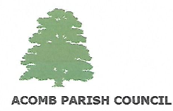
“Haddrigg”
9 The Riggs
Corbridge
NE45 5JX
Chairman: Cllr Charles Enderby
Clerk to the Council: Bill Grigg
Tel: 07918073281
Email: griggbill@gmail.com
I hereby give notice that the next Council meeting will be held on Wednesday 2nd September 2026 at 7pm in the Village Hall, Acomb.
Residents wishing to ask the Council a question are asked to send it to the Clerk 48 hours before the Council meeting
Residents are most welcome to attend.

Bill Grigg
Clerk to the Council

Agenda
- Welcome and Introductions
- Apologies
- Declaration of Interests
- Residents Questions
- The Minutes of the Council Meeting held on 23rd July 2026
- Any Matters Arising from the Minutes of the Council meeting held on 23rd July 2026
- Report from County Cllr T. Cessford
- Financial Matters
- Feedback from consultation in regard to village bus service
- Planning Matters
- Any correspondence not already circulated to all Councillors
- Any urgent business allowed by the Council Chairman
- Date of Next Meeting (4th November 2026)

